Linux Basic Commands Assignment
Practical Submission with Commands, Explanation, and Screenshots

Submitted By | ____________________________
Course / Subject | Linux Basics
Date | 25 June 2026
GitHub Repository Link | Paste your GitHub repo link here

Introduction
In this practical assignment, I used the Ubuntu terminal to perform basic Linux tasks such as creating files, viewing system file content, searching text, compressing folders, downloading a file, changing permissions, and using environment variables. I have added the commands along with the output screenshots for verification.

1. Creating and Renaming Files/Directories
Objective: To create a directory, create an empty file inside it, and then rename the file.
Commands Used
mkdir test_dir
ls
cd test_dir
touch example.txt
mv example.txt renamed_example.txt
ls
Explanation
I created a directory named test_dir using mkdir. After moving inside the directory, I created an empty file named example.txt using touch. Then I renamed the file to renamed_example.txt using mv and confirmed the result using ls.
My Observation: The final output shows renamed_example.txt inside test_dir, so the file creation and rename task was completed successfully.
Screenshot 1
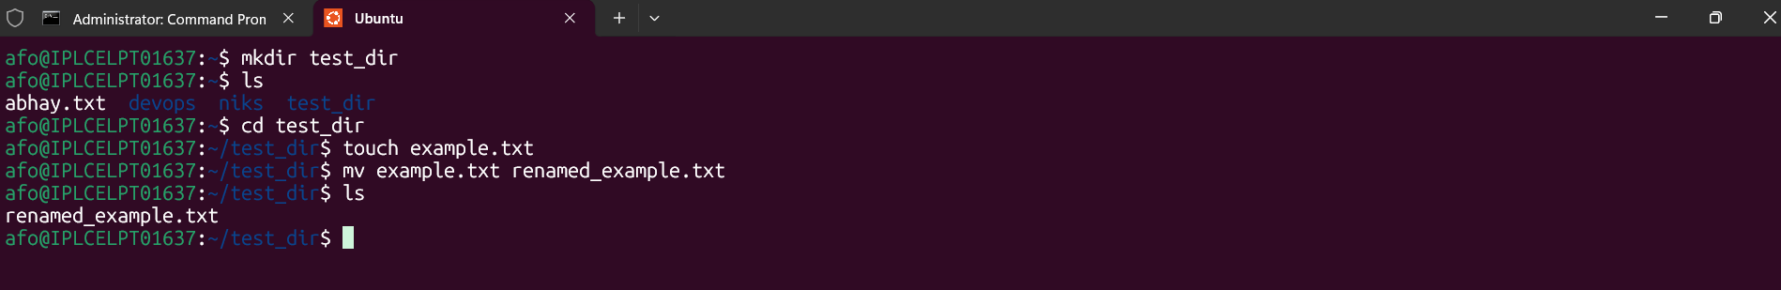

2. Viewing File Contents
Objective: To display the full content of /etc/passwd and then display only its first and last 5 lines.
Commands Used
cat /etc/passwd
head -n 5 /etc/passwd
tail -n 5 /etc/passwd
Explanation
The /etc/passwd file is a default Linux system file that stores basic user account information. I used cat to display the full file content, head -n 5 to display the first 5 lines, and tail -n 5 to display the last 5 lines.
My Observation: The terminal output shows the complete file first, then the first five lines, and finally the last five lines of /etc/passwd.
Screenshot 2
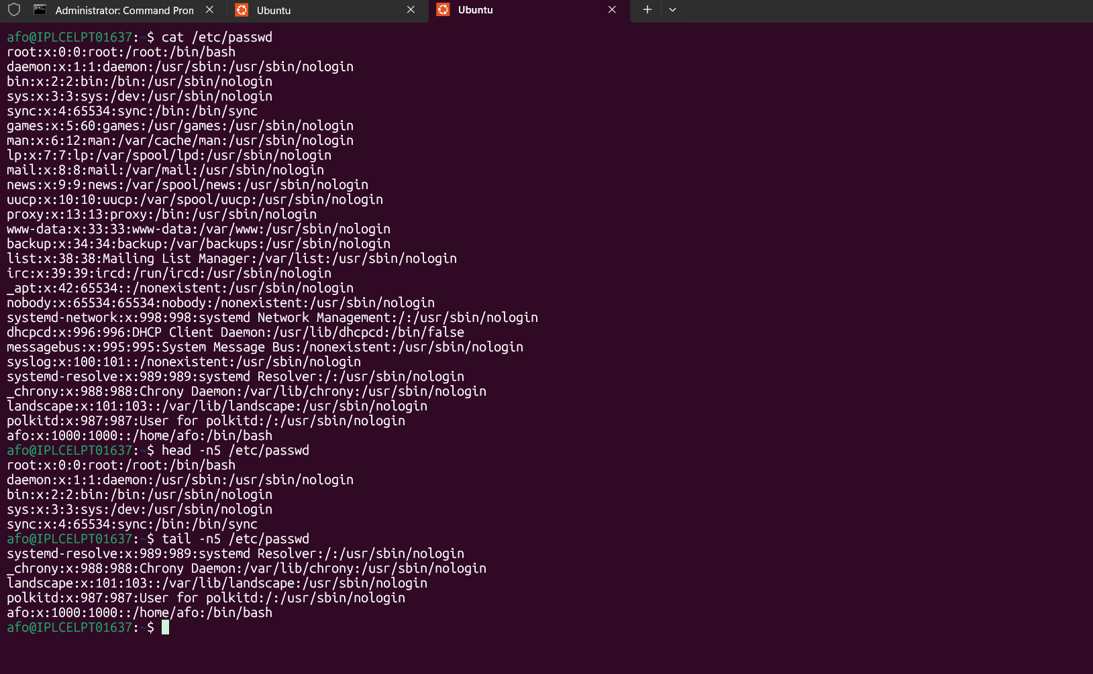

3. Searching for Patterns
Objective: To search for all lines containing the word root inside /etc/passwd.
Commands Used
grep "root" /etc/passwd
Explanation
The grep command is used to search text patterns inside files. Here, I searched for the word root in the /etc/passwd file. The matching line was displayed in the terminal output.
My Observation: The output shows the root user entry, which confirms that grep found the word root successfully.
Screenshot 3
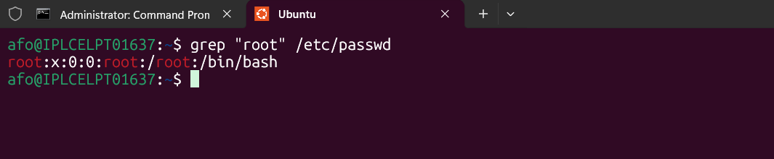

4. Zipping and Unzipping
Objective: To compress the test_dir directory into a zip file and extract it into another directory.
Commands Used
zip -r test_dir.zip test_dir
mkdir unzipped_dir
unzip test_dir.zip -d unzipped_dir
ls unzipped_dir
Explanation
I used zip -r to compress the complete test_dir directory into test_dir.zip. After that, I created a new directory named unzipped_dir and extracted the zip file into it using unzip with the -d option.
My Observation: The output shows that the folder and renamed_example.txt file were added into the zip archive and then extracted successfully into unzipped_dir.
Screenshot 4
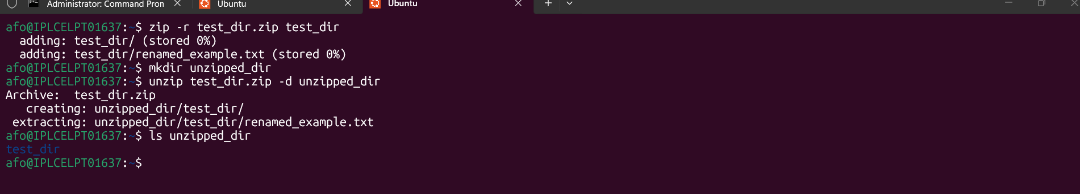

5. Downloading Files
Objective: To download a file from a URL using wget.
Commands Used
wget -O sample.txt https://example.com
Explanation
I used wget to download content from a URL. The -O option was used to save the downloaded content with the filename sample.txt. This is useful when we want to choose our own output filename.
My Observation: The output shows 200 OK and confirms that sample.txt was saved successfully.
Screenshot 5
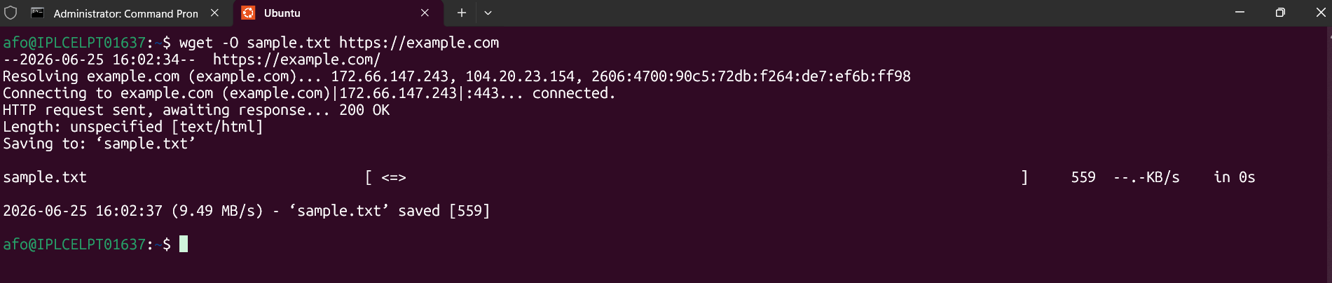

6. Changing Permissions
Objective: To create a file and make it read-only for everyone using chmod.
Commands Used
touch secure.txt
chmod 444 secure.txt
ls -l secure.txt
Explanation
I created a file named secure.txt using touch. Then I used chmod 444 to give read-only permission to the owner, group, and others. Finally, I verified the permission using ls -l.
My Observation: The permission -r--r--r-- confirms that the file is read-only for everyone.
Screenshot 6
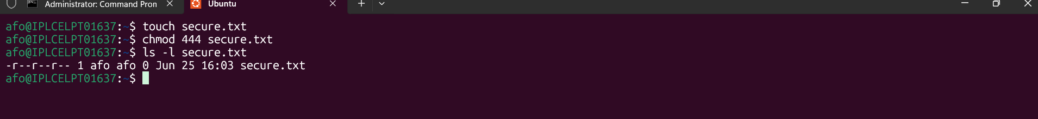

7. Working with Environment Variables
Objective: To create an environment variable and display its value.
Commands Used
export MY_VAR="Hello, Linux!"
echo $MY_VAR
Explanation
I used export to create a temporary environment variable named MY_VAR with the value Hello, Linux!. Then I used echo $MY_VAR to print the value in the terminal.
My Observation: The output displays Hello, Linux!, which confirms that the environment variable was set correctly.
Screenshot 7
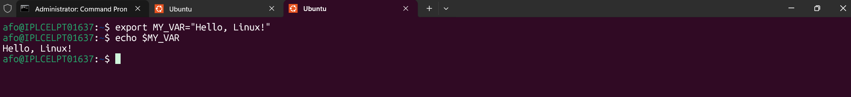

Conclusion
Through this practical, I performed the required basic Linux operations and verified each command using terminal output. This helped me understand how files, directories, permissions, searching, compression, downloading, and environment variables work in Linux.
GitHub Repository Link: Paste your GitHub repo link here

